**REPORT**

**Political Juggernauts: A Quantitative Analysis Of Candidates In The 2019 Lok Sabha Elections.**

**1.Introduction:**

**1.1 Overview:**

**If you are looking for information on a specific research paper or publication with this title, I would recommend the following steps:**

**1. Check Academic Databases: Search academic databases, such as Google Scholar, JSTOR, or university libraries, for the specific paper or publication. These sources often provide access to academic research articles and papers.**

**2. Contact Authors or Research Institutions: If you have the names of the authors or the research institution associated with this paper, you can try to contact them directly for more information or access to the paper.**

**3. Look for Official Reports: The Election Commission of India and various academic institutions often release official reports and studies related to Indian elections. These reports can provide valuable insights and quantitative analyses.**

**4. Academic Journals: Check academic journals in the field of political science, elections, or Indian politics. They might have published articles related to quantitative analyses of the 2019 Lok Sabha elections.**

**5. Government Publications: Government agencies and research bodies in India may have published reports on election analyses that include quantitative data and insights.**

**1.2 Purpose:**

**The purpose of a research paper with this title might include:**

**Candidate Performance Analysis: To examine the performance of individual candidates who contested the 2019 Lok Sabha elections. This could involve assessing factors like their electoral success, vote share, margin of victory, and more.**

**Quantitative Data Examination: The study might aim to analyze and quantify various aspects of candidate performance using data such as the number of votes received, demographics, campaign expenses, and other relevant variables.**

**Identifying Political Juggernauts: The term "political juggernauts" suggests a focus on candidates who wield significant influence or are exceptionally successful in Indian politics. The research could aim to identify and profile these influential candidates.**

**Election Trends and Patterns: The study could seek to uncover broader trends and patterns in candidate performance, such as the success of incumbents, the role of political parties, and the impact of various campaign strategies.**

**Informing Political Strategy: Such research can be valuable for political parties and candidates, as it can provide insights into the factors contributing to electoral success or failure. Understanding the characteristics and strategies of successful candidates can inform future political campaigns.**

**Academic Contribution: Research papers like these contribute to the academic study of politics, offering data-driven insights into the functioning of democratic processes and the role of individual candidates in shaping electoral outcomes.**

**The specific goals and scope of the study would depend on the research questions and objectives set by the authors. To understand the precise purpose and findings of a paper with this title, you would need to locate and review the actual publication or research paper, as it might provide a more detailed explanation of its aims and methodology.**

**2.Problem definition and design thinking:**

**2.1.Empathy Mapping:**

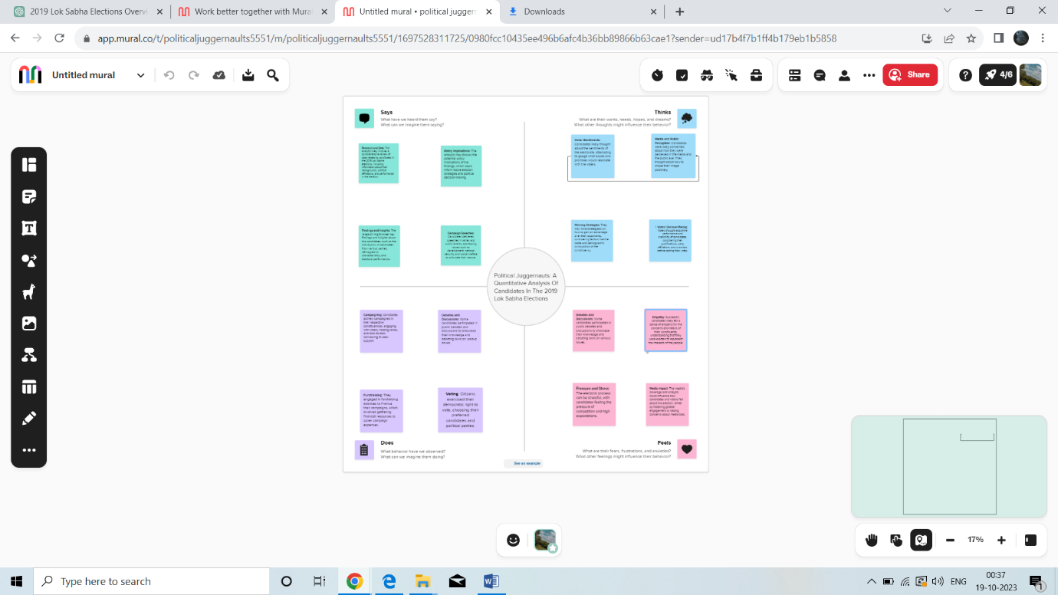

**2.2.Brainstroming:**



**3.Result:**

**3.1.Dashboard:**

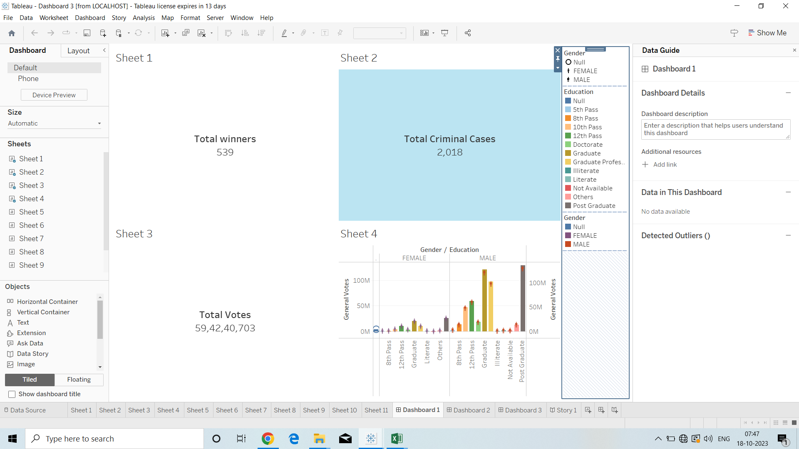

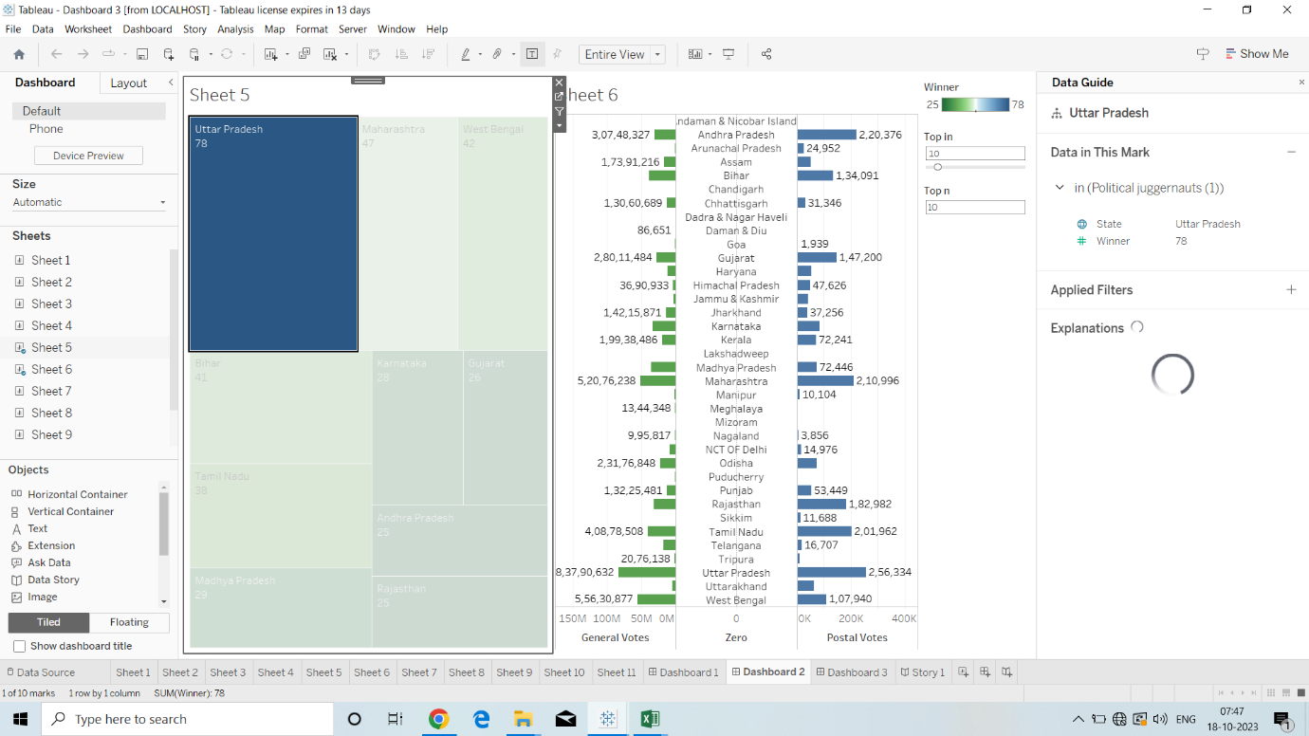

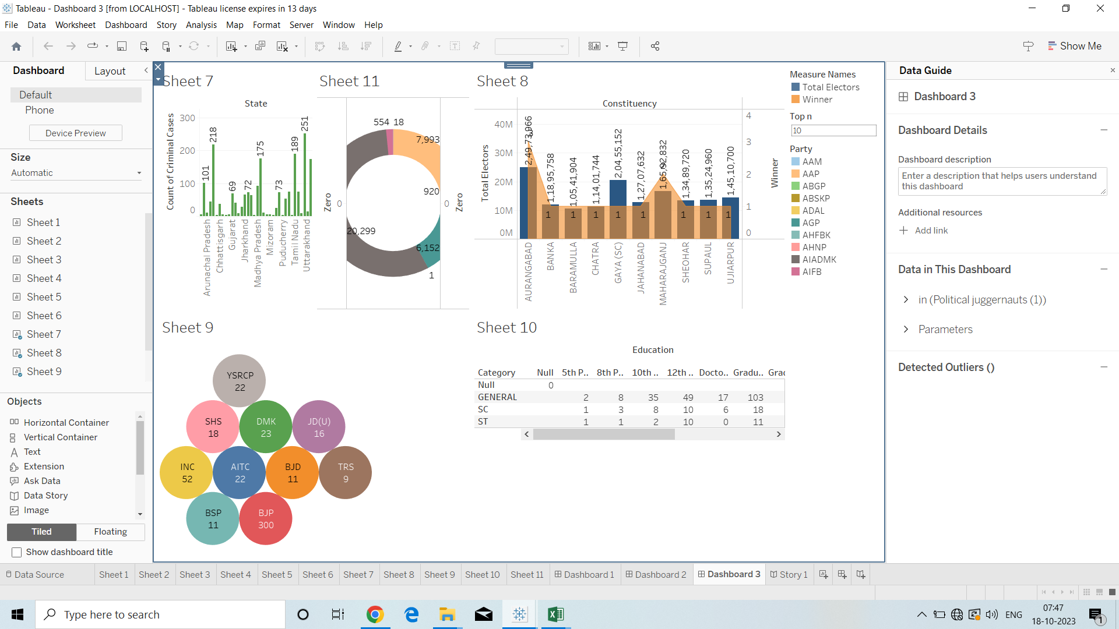

**3.2.Story:**

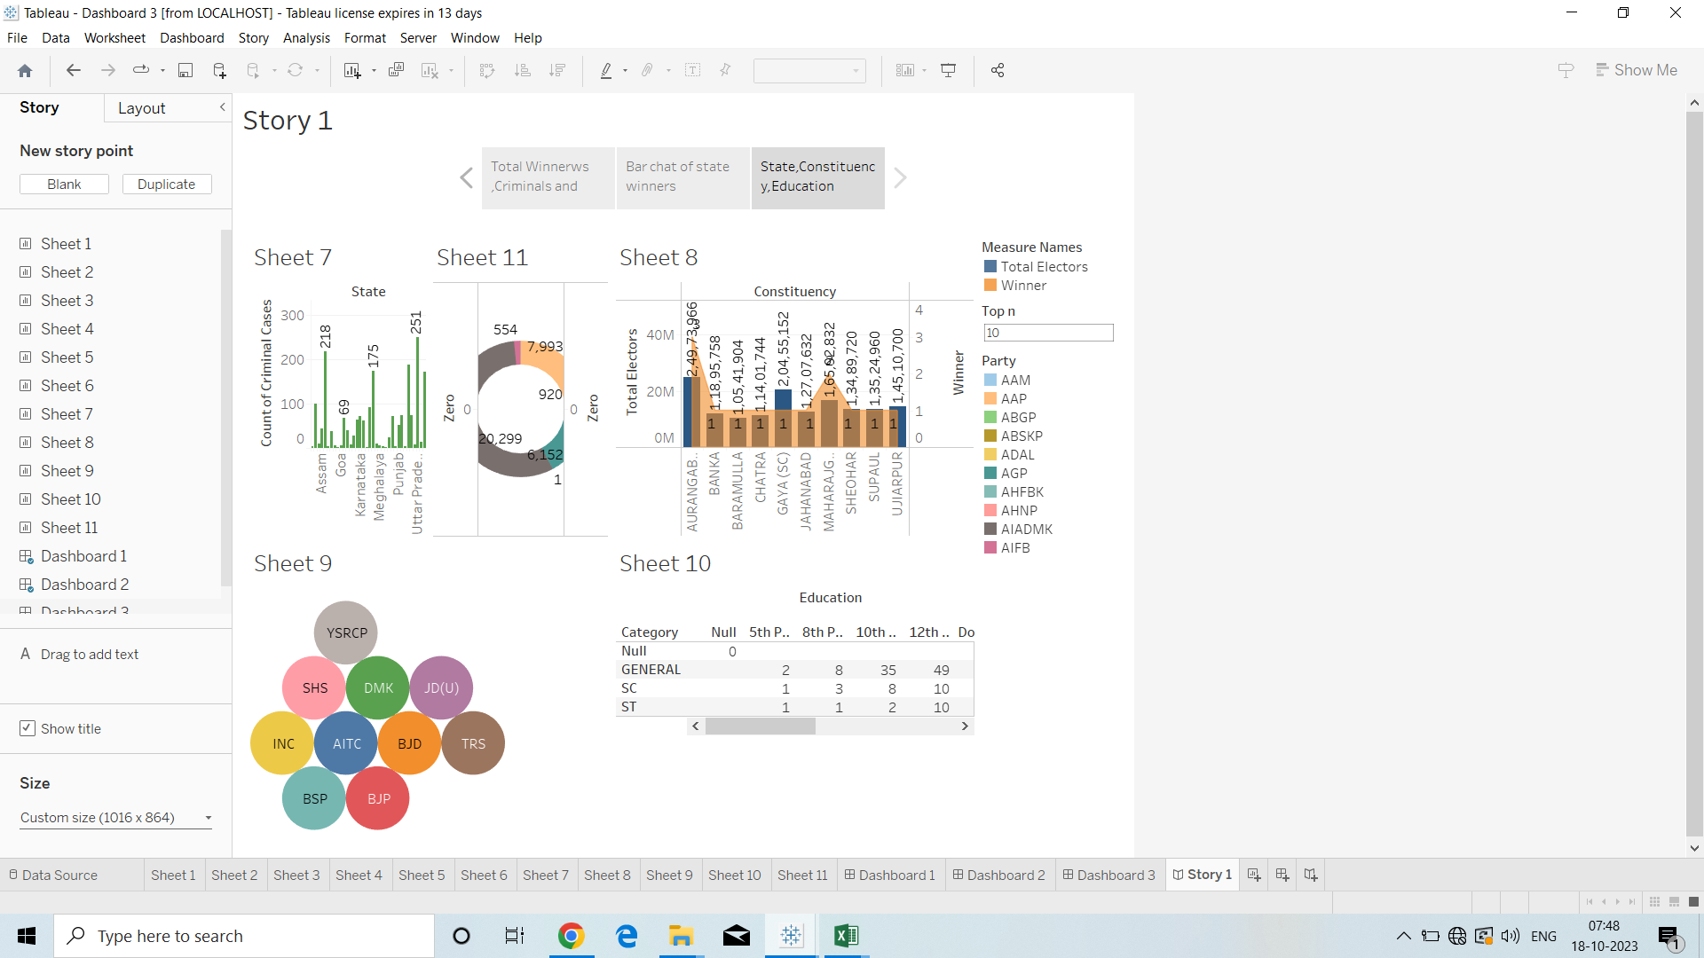

**4.Advantages and Disadvantages:**

**4.1.Advantages:**

**Certainly, here are some potential advantages of conducting a quantitative analysis of candidates in the 2019 Lok Sabha elections or any similar political research:**

1. **Data-Driven Insights: Quantitative analysis relies on empirical data, allowing researchers to draw evidence-based conclusions. This data-driven approach can provide more objective and reliable insights into the election process.**
2. **Understanding Electoral Dynamics: Quantitative analysis can reveal patterns and trends in candidate performance, vote share, and campaign strategies. This understanding is valuable for researchers, political analysts, and policymakers.**
3. **Identifying Key Influencers: By analyzing quantitative data, researchers can identify influential candidates or factors that played a pivotal role in election outcomes. This information can be useful for both political strategists and the general public.**
4. **Policy Implications: The research can shed light on how electoral outcomes relate to policy choices and government effectiveness. This can help inform policy decisions and governance strategies.**
5. **Political Strategy Guidance: Political parties and candidates can benefit from a quantitative analysis of past elections. It can help them fine-tune their campaign strategies, target specific demographics, and understand what works and what doesn't.**
6. **Accountability and Transparency: Quantitative analysis can reveal irregularities or discrepancies in the electoral process, promoting accountability and transparency in the democratic system.**
7. **Academic Contribution: Research papers in political science contribute to the academic understanding of politics and elections. They expand the body of knowledge and can be used for future research and reference.**
8. **Informed Electorate: The research can also serve an educational purpose by providing voters with a deeper understanding of the electoral process and the factors that influence it. This can help voters make more informed choices.**
9. **Comparative Studies: Quantitative data allows for comparisons between different elections, regions, or countries. This comparative analysis can provide insights into variations in electoral behavior and outcomes.**
10. **Predictive Power: Advanced quantitative models can sometimes predict future trends and outcomes based on historical data. This can be valuable for political forecasting and planning.**
11. **Policy Evaluation: Researchers can use quantitative analysis to assess the impact of specific policies or government actions on election results, helping to evaluate the effectiveness of government initiatives.**
12. **Evidence for Reform: If the research identifies areas of concern or inefficiency in the electoral process, it can provide evidence for reform efforts and improvements in the democratic system.**

**It's important to note that the specific advantages of quantitative analysis in this context will depend on the research objectives, the quality of the data collected, and the rigor of the analysis conducted. The utility of such research often depends on its relevance and the extent to which its findings are used to inform policy, political strategies, or academic discussions.**

**4.2.Disadvantages:**

**While quantitative analysis of candidates in the 2019 Lok Sabha elections and similar political research can provide valuable insights, it also comes with certain disadvantages and limitations:**

1. **Simplification of Complex Phenomena: Quantitative analysis often simplifies complex political, social, and economic phenomena into numerical data, potentially losing important nuances and context.**
2. **Data Limitations: The quality and availability of data can be a significant limitation. Inaccurate or incomplete data can lead to biased or misleading results.**
3. **Overlooking Qualitative Aspects: Quantitative analysis may neglect qualitative aspects, such as candidate charisma, campaign messaging, and voter sentiment, which can be critical in politics.**
4. **Assumption of Linearity: Many quantitative models assume linear relationships between variables, which may not always hold true in real-world politics. Political dynamics are often nonlinear and context-dependent.**
5. **Limited to Available Data: Researchers are constrained by the data that is available. Some critical factors or variables may not be measured or may be challenging to quantify.**
6. **Causation vs. Correlation: Quantitative analysis can identify correlations between variables, but it cannot always establish causation. It's essential to be cautious when interpreting causality.**
7. **Sensitivity to Model Choice: The choice of statistical models and methodologies can significantly impact the results. Different models can yield different conclusions.**
8. **Lack of Contextual Understanding: Relying solely on quantitative data may result in a lack of in-depth understanding of the political, social, and cultural context in which elections take place.**
9. **Issues of Measurement: Defining and measuring political phenomena, such as candidate effectiveness or voter sentiment, can be challenging. Different measurement choices can lead to different results.**
10. **Data Bias: Data can be biased due to factors like non-response bias, sampling bias, and data collection methods. This bias can affect the validity of the analysis.**
11. **Generalization and Ecological Fallacy: Aggregating data at a high level, such as at the national level, can lead to the ecological fallacy, where individual-level trends are inaccurately inferred from group-level data.**
12. **Resource-Intensive: Quantitative analysis can be resource-intensive in terms of data collection, analysis, and software/tools required. This can be a limitation for smaller research projects.**
13. **Oversimplification of Political Behavior: It might oversimplify voter behavior by reducing it to numerical variables, while political decisions can be driven by complex emotional and psychological factors.**
14. **Ethical and Privacy Concerns: Gathering and using data for research purposes can raise ethical concerns, particularly when it comes to issues of privacy and data security.**
15. **Temporal Constraints: Political research often operates on tight timelines, and conducting thorough quantitative analysis may not always be feasible within these constraints.**
16. **Dynamic Nature of Politics: Political landscapes evolve rapidly. Quantitative analysis may not capture changes that occur after the data is collected.**

**To address these disadvantages, many researchers use a mixed-methods approach, combining quantitative analysis with qualitative research to provide a more comprehensive understanding of political phenomena. Additionally, the limitations and potential biases associated with quantitative analysis should be acknowledged and discussed transparently in research findings.**

**5.Applications:**

**Quantitative analysis of candidates in the 2019 Lok Sabha elections and similar political research can have various practical applications and implications. Here are some key applications:**

1. **Election Strategy and Campaign Planning: Political parties and candidates can use quantitative analysis to develop data-driven election strategies. By studying past election data, they can identify factors that contribute to electoral success, helping them target specific demographics and allocate campaign resources more effectively.**
2. **Candidate Selection: Political parties can use quantitative analyses to evaluate the past performance of potential candidates, helping them make informed decisions about candidate selection for future elections.**
3. **Voter Targeting: Data-driven voter targeting is crucial in modern politics. Quantitative analysis helps identify key demographics, swing voters, and areas where a party or candidate should focus their campaign efforts.**
4. **Policy Formulation: Analysis of election data can inform policy formulation by revealing the issues that matter most to voters. Politicians can use this information to design policies that align with public sentiment.**
5. **Constituency Development: Elected representatives can use quantitative data to prioritize development initiatives in their constituencies based on the needs and preferences of their constituents.**
6. **Post-Election Analysis: After an election, political analysts and parties can use quantitative analysis to understand the reasons for victory or defeat. This can lead to course corrections and improvements for future elections.**
7. **Academic Research: Political scientists and researchers use quantitative analysis to contribute to the academic understanding of politics and elections. This research can provide insights into voting behavior, electoral systems, and political dynamics.**
8. **Government Accountability: Quantitative data can be used to hold governments accountable for their performance. If candidates or parties make specific promises during elections, quantitative analysis can track whether they fulfill those promises.**
9. **Voter Education: Educational institutions and civic organizations can use election data analysis to teach citizens about the electoral process, the significance of voting, and the impact of their choices.**
10. **Media Coverage and Polling: Media outlets and polling organizations use quantitative analysis to predict election outcomes, inform their reporting, and provide the public with insights into the political landscape.**
11. **Forecasting and Prediction: Quantitative models can be used to make forecasts and predictions about election outcomes, enabling stakeholders to prepare for different scenarios.**
12. **Post-Election Surveys: Researchers and pollsters often conduct post-election surveys to collect quantitative data on voter behavior and attitudes. This information can be valuable for understanding the electorate's pulse.**
13. **International Comparisons: Researchers and policymakers may use quantitative data to compare electoral systems, political behavior, and election outcomes across different countries, helping to draw lessons and make international comparisons.**
14. **Policy Evaluation: Quantitative data can be employed to evaluate the effectiveness of specific policies or government programs by assessing their impact on election results and voter perceptions.**
15. **Democratic Process Improvement: Findings from quantitative analyses can inform recommendations for improving the democratic process, such as changes in electoral systems or campaign finance regulations.**

**Quantitative analysis in politics serves not only to explain past election outcomes but also to shape future political decisions, policies, and strategies. It plays a vital role in the functioning of democratic systems and the continuous evolution of political landscapes.**

**6.Future Scope:**

**The future scope of quantitative analysis in the realm of politics, especially in the context of elections like the Lok Sabha elections, is quite promising. Here are some key areas where the field is likely to evolve and expand:**

**Advanced Data Analytics: With the increasing availability of data, including social media data and real-time polling information, the use of advanced data analytics and machine learning techniques will become more prevalent. These techniques can provide deeper insights into voter behavior and campaign strategies.**

**Predictive Modeling: The development of more accurate predictive models for election outcomes will continue to be a focus. Improved modeling can help political parties allocate resources more effectively and make strategic decisions.**

**Big Data Integration: The integration of big data from various sources, such as social media, voter databases, and polling data, will enable more comprehensive analyses and predictions.**

**Geospatial Analysis: Geospatial analysis, including the use of Geographic Information Systems (GIS), can help in understanding spatial patterns in election results and voter behavior. This can aid in constituency-level strategies.**

**Behavioral Insights: The field of political psychology and behavioral economics will play a larger role in understanding voter behavior and decision-making. This can inform campaign messaging and political strategies.**

**Social Media Influence: Research into the influence of social media on elections will continue to grow. Understanding how online platforms affect voter sentiment and mobilization will be crucial.**

**Election Technology: Advancements in election technology, including electronic voting machines and secure online voting systems, will require quantitative analysis to assess their impact on electoral integrity and voter turnout.**

**Voter Demographics: In an increasingly diverse and interconnected world, understanding voter demographics and their changing preferences will be essential. Quantitative analysis can help identify demographic shifts and their electoral implications.**

**Election Forensics: Quantitative methods will continue to be used to detect irregularities, fraud, and potential malpractices in the electoral process, enhancing the transparency and integrity of elections.**

**Comparative Studies: Cross-country comparisons and international research collaboration will become more common, providing a global perspective on electoral processes and political behavior.**

**Policy Impact Assessment: Quantitative analysis can be applied to assess the impact of specific policies and government actions on election outcomes and public opinion, aiding in better governance.**

**Citizen Engagement: Research on methods to increase voter engagement and turnout will remain important, especially in the context of declining voter participation in some democracies.**

**Ethics and Privacy Concerns: With the growing concern over data privacy and ethical considerations, there will be increased attention to ensuring that quantitative analysis in politics respects privacy and ethical standards.**

**Interactive Visualization: The development of interactive and user-friendly data visualization tools can make quantitative political analyses more accessible to a broader audience, including policymakers and the general public.**

**Election Reform Advocacy: Quantitative analysis can provide evidence for election reform initiatives, such as changes in electoral systems, campaign finance regulations, and voter access.**

**Impact on Decision-Making: The future of quantitative analysis in politics lies in its ability to directly influence political decisions, strategies, and policies. As political parties and candidates become more data-savvy, the field will continue to shape political landscapes.**

**The integration of technology, data, and quantitative methods into the political process is likely to be a defining feature of future elections and political decision-making. As data becomes more abundant and sophisticated analytical techniques emerge, the scope for quantitative analysis in politics will expand, providing valuable insights and influencing political outcomes.**

**7.Conclusion:**

**In conclusion, quantitative analysis of candidates in the 2019 Lok Sabha elections and similar research plays a pivotal role in understanding and shaping the political landscape. It offers a data-driven approach to investigating various aspects of elections, candidate performance, and voter behavior. The future scope of quantitative analysis in politics is promising, with several exciting possibilities on the horizon:**

**Advanced Analytics and Technology: The integration of advanced data analytics, machine learning, and big data will provide deeper insights into political behavior and election outcomes.**

**Predictive Modeling: More accurate predictive models will help political parties and candidates make strategic decisions, allocate resources efficiently, and optimize their campaign strategies.**

**Behavioral Insights: Research in political psychology and behavioral economics will aid in understanding voter behavior, making campaign messaging more effective, and crafting persuasive political strategies.**

**Election Technology: Advancements in election technology will require ongoing quantitative analysis to assess their impact on electoral integrity and voter engagement.**

**Transparency and Ethics: Ethical considerations and data privacy will continue to be at the forefront, ensuring that quantitative analysis respects ethical standards and privacy concerns.**

**Cross-Country Comparisons: International collaborations and cross-country comparisons will provide a global perspective on electoral processes and political dynamics.**

**Citizen Engagement: Efforts to increase voter engagement and turnout will remain a focus, addressing the challenge of declining voter participation in some democracies.**

**Policy Impact Assessment: Quantitative analysis can assess the impact of policies and government actions on election outcomes, contributing to better governance.**

**Interactive Visualization: Interactive data visualization tools will make political analyses more accessible to policymakers and the general public, enhancing transparency.**

**Decision-Making Influence: The future of quantitative analysis in politics lies in its ability to directly influence political decisions, strategies, and policies.**

**Quantitative analysis in politics not only helps explain past election results but also shapes the future by informing political strategies, influencing policy decisions, and enhancing transparency in the democratic process. As technology and data analytics continue to evolve, quantitative political analysis will remain a critical tool in understanding and influencing political landscapes.**